EXPERIMENT-5

Aim: write SQL queries for the aggregate functions(sum,count,min,max,avg)

Creating a table:

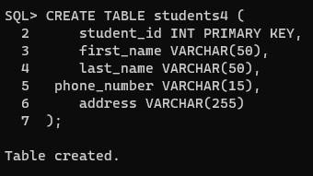 Inserting values into table :

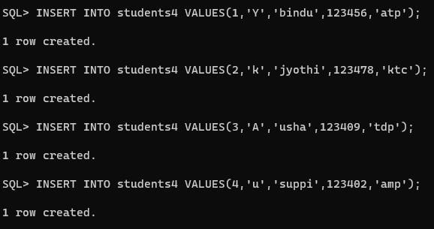

Selecting table :

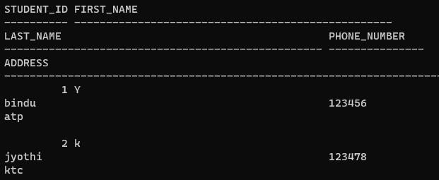

Sum();

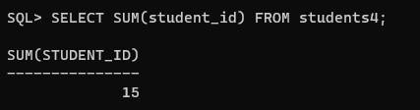

Avg();

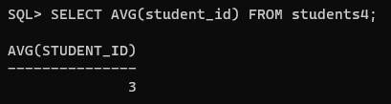

Min();

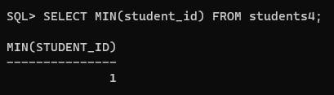

Max();

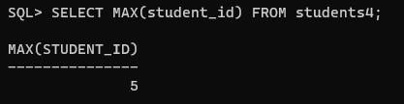

Count();

